Hubble constant analysis

INTRO
The goal of this work was to analyse astrophysical data to produce an accurate value of the rate of expansion of the universe (Hubble constant).
The equation for the Hubble constant is given as:
$v_{rec }=H_{0}D_{gal}$ (1)
Where $v_{rec }$is the recession velocity of a given galaxy, $H_{0}$ is the Hubble constant, and $D_{gal}$ is the distance of the galaxy from us. $v_{rec}$ and $D_{gal}$ is given in the final part of the work when looking at other galaxies. However, to obtain a value for distance in the nearby galaxy NGC4527, distance must be derived from data about Cepheid variables in that galaxy using their absolute magnitude.
The equation for the absolute magnitude of a Cepheid is:
$M=α\log_{10}{}P +β$ (2)
Where $α$and $β$are both constants and $P$is the period of the Cepheid.
Relating the absolute magnitude to distance from us, the equation is:
$M=m-5\log_{10}{}d_{pc}+5-A$ (3)
Where $m$is the apparent magnitude, $d_{pc}$ is distance in parsecs, and $A$is the extinction.
To give distance in parsecs from parallax.
$d_{pc}=\frac{1000}{parallax}$ (4)
STEP 1
The aim in step 1 was to come up with values and uncertainties in $α$and $β$using data from Cepheids within the Milky Way galaxy. The data extracted from the file given was on Cepheids’ parallax with error, period$\left(P\right)$, apparent brightness$\left(m\right)$, and extinction$\left(A\right)$ with error.
Initially, a value of $M$needed to be found using equation (3). The uncertainty of this could be found both analytically and numerically. First, I did this analytically, through using the mean value for distance and its uncertainty within the propagation of uncertainties formula, differentiating $M$ with respect to $d$. Once this was done, $M$could be plotted against $\log{1}0P$ by defining the linear function x1, m1, b1 of the form y = mx + b, and using the curve_fit function from scipy to fit the defined function to $M$and $\log{1}0P$ . The gradient and y-intercept of this would give $α$and $β$respectively, which are found by extracting the parameters for the gradient and y-intercept. The uncertainties in $α$and $β$ are then calculated using the square root of the diagonal elements of the covariance matrix.
This gave the values for alpha and beta: $α=-2.41±0.17$ $β=-1.61±0.15$
Once this was completed the graph could be printed;
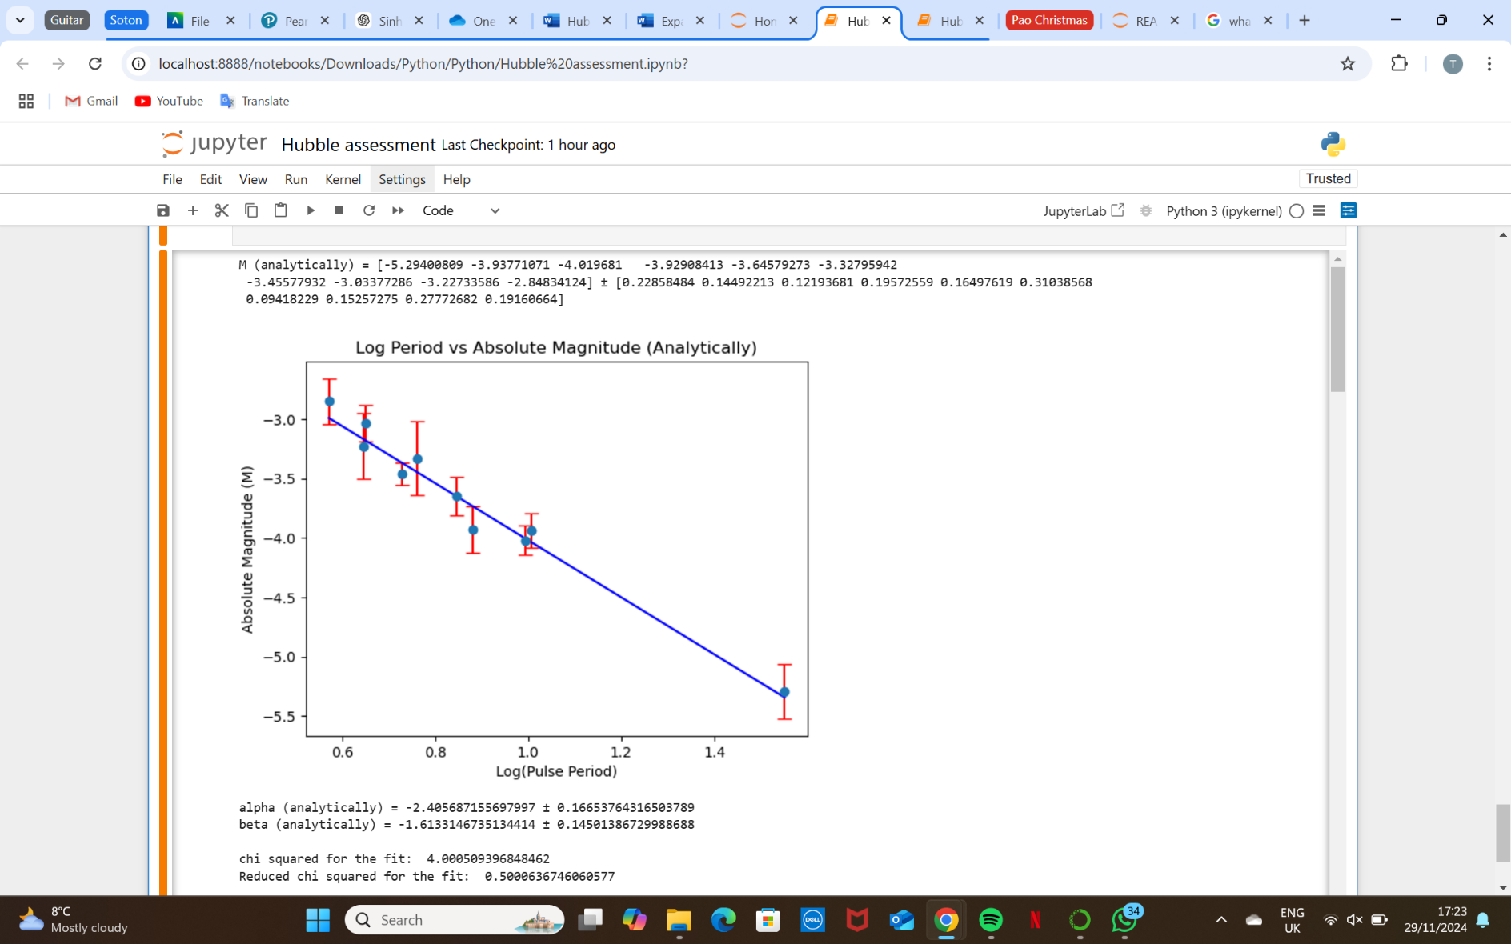
To analyse the fit the chi squared test was used. This gave the value for chi squared as 4.000509396848462. Which just about fits within the expected range of 8 ± 4, meaning the data was a good fit in relation to the theoretical model.

Now to get the numerical uncertainty in $M$, the mean and standard deviation of distance was found for each index ‘i’, as well as drawing 10,000 random values from a normal distribution centred around the mean distance with the standard deviation. The same was done for the extinction $A$, which were put into equation (3) to give values for $M$, from which the mean and standard deviation were found.
Alpha and beta with their uncertainties were then found using the same steps as with the analytical M previously.
This gave the values for alpha and beta: $α=-2.41±0.17$ $β=-1.60±0.15$
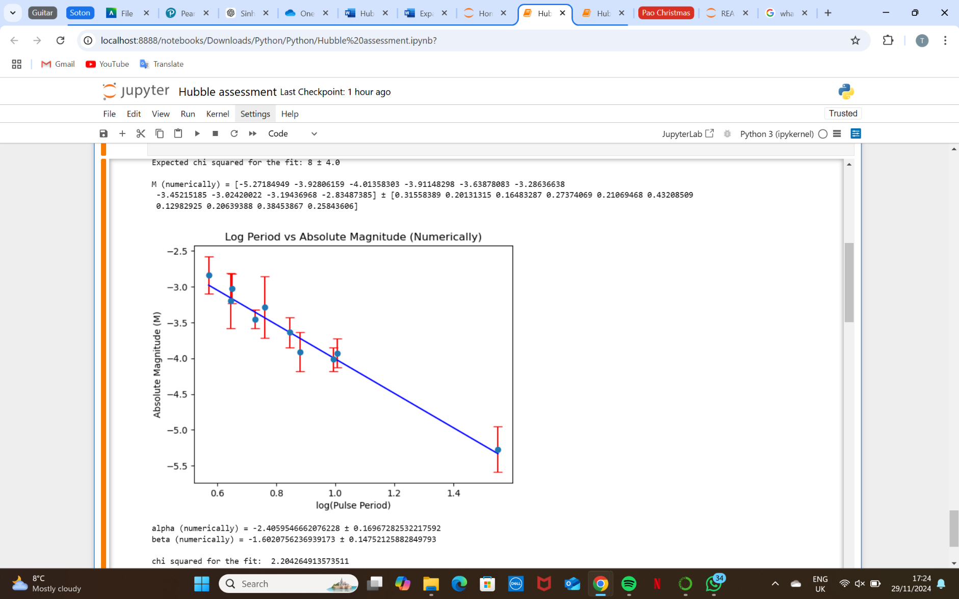
Performing the chi squared test for the fit gave a value of 2.204264913573511, which did not fit into the expected range of 8 ± 4, meaning the uncertainties are overestimated, which may show a problem in some calculations.
Using the analytically found uncertainties in $M$is seen to have given a much better chi squared value when plotting $M$ against $\log{P}$. This could show it to be a better way of finding uncertainties, however, could have just been caused by problems in the code for the numerical uncertainties. It would be reasonable to reject the values obtained for alpha and beta found using numerical uncertainties, however I continued to use both as they gave similar values anyway.

STEP 2
The aim in step 2 was to use data from the galaxy NGC4527 and use the relationship between apparent and absolute magnitude, extinction and distance, to obtain an estimate of the distance in parsecs, along with an estimate of error.
First, distance was calculated using the values of alpha and beta found from analytical uncertainty calculations. To identify any outliers in this data, distance could be plotted on its own, this showed that the 7th value was an outlier.

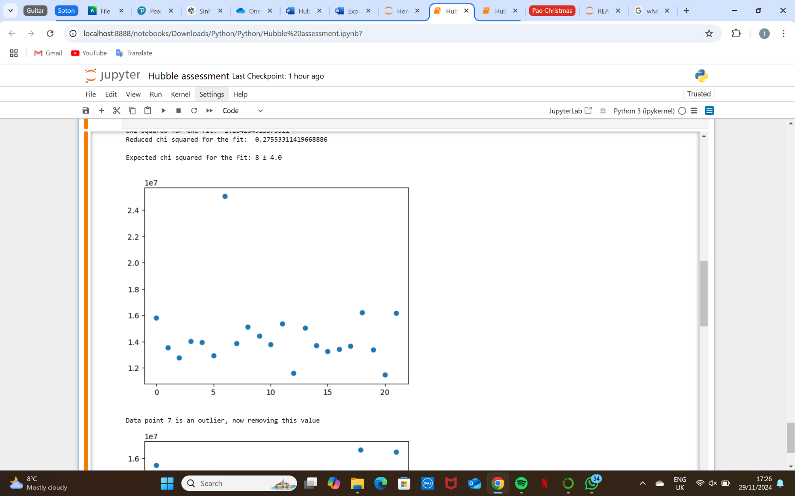
Therefore, I removed this value from the data set, plotting again to check this worked showed no other outliers in the scatter graph.
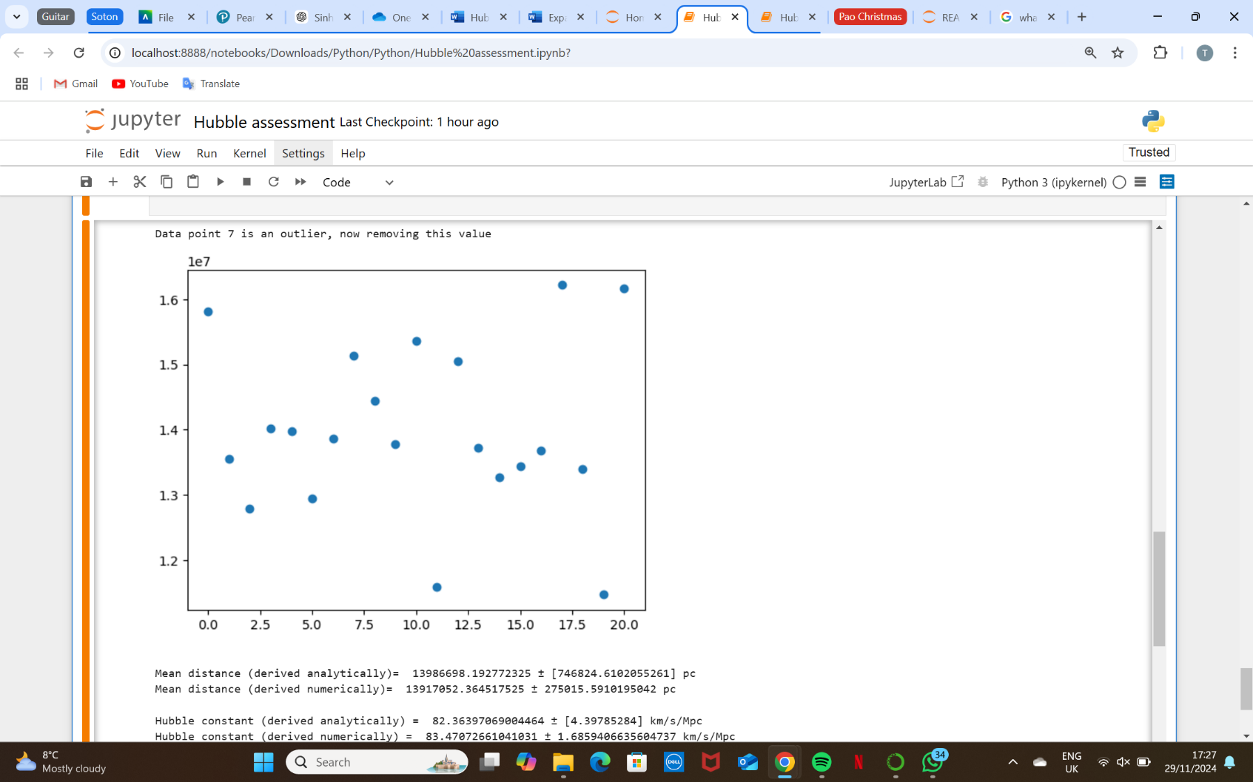
Now, continuing with calculations, the mean was found to give a good estimate of the distance of this galaxy from us, as well as the uncertainty of this using propagation of uncertainties, continuing with using the analytical method of finding uncertainties, and then printing the mean cepheid distance with its uncertainty which gave: $mean d=13986698.19±746824.61pc$

After this, the values of alpha and beta using numerical uncertainty calculations were used. Distance could then be calculated, removing the outlier, along with finding its mean to give an estimated distance of the galaxy from us, and its uncertainty using np.mean and np.std respectively where the standard deviation is the uncertainty, giving us:$mean d=13917052.36±275015.59pc$

STEP 3
The aim in the final step was to obtain an estimate for the Hubble constant with uncertainties $\left(H_{0}\right)$ using the distance previously obtained along with the recession velocity$\left(1152 kms^{-1}\right)$. Then to do the same for other galaxies with data from a given data set to obtain a more accurate estimate of the Hubble constant with uncertainties.
Using previous values found analytically for the value, along with propagation of uncertainties to find it analytically gave a value for Hubble constant of $82.36±4.40 km/s/Mpc$.
Using numerical values in the calculation, and then finding the uncertainty through the standard deviation, gave $83.47±1.69 km/s/Mpc$.
These values are only found using one galaxy (NGC4527), a more accurate value would be obtained using data from multiple galaxies. Data on recession velocity, distance with error, was extracted from a file and was edited to also include the data from NGC4527.
Once again using curve_fit to fit a defined linear function to recession velocity and distance and allowing them to be plotted against each other. Extracting the gradient here would give 1/$H_{0}$ , allowing a value for the Hubble constant to be found. The uncertainty of this can be found by square rooting the diagonal in the covariance matrix.

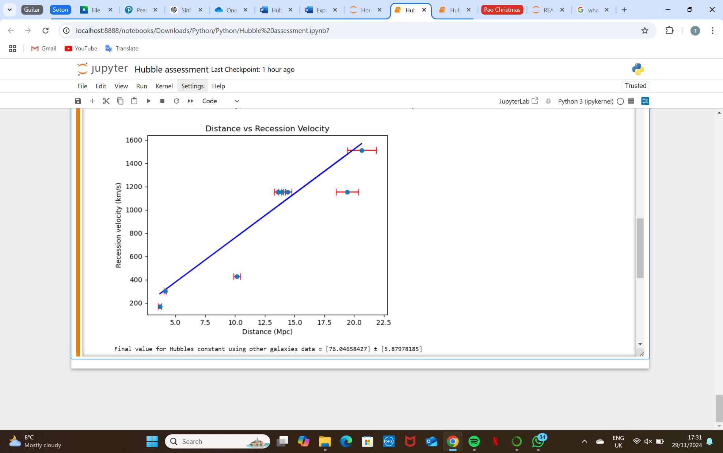
The value found for Hubble constant is: $76.05±5.88$.

The chi squared value for this fit was 441.1495932435942 which is very far from the expected range 7 ± 3.7416573867739413 using 8 degrees of freedom.
This shows a very bad fit to the theoretical model, showing that the errors were massively underestimated. A possible solution could be to use a wider data set which would give more accurate values and wider errors.
Finally, I calculated and plotted the residuals between the observed and predicted values (line of best fit) to see if there were any outliers.
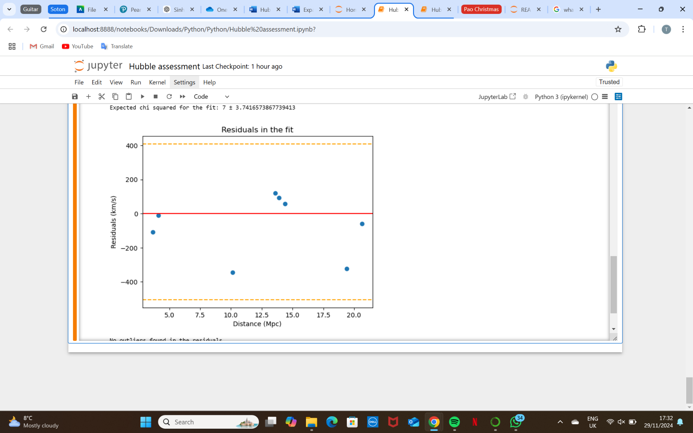
This showed no outliers, just that multiple data points were quite far from predicted values, further supporting the fact more data is needed to get a more accurate model for the Hubble constant

